**Report of Role wise task Description for the Application for registration of Migrant Labour Service.**

|  |  |  |  |
| --- | --- | --- | --- |
| **Sl. No.** | **Role Name** | **Task Name** | **Task Description** |
| 1. | **Executive Officer** |  |  |
| 1a | TM-2 | Application Receipt By Executive Officer | Supervisory Level of Executive Officer scrutinise the application.  If everything is okay then Executive Officer (Sl. No.- 1b) with Delivers for Issuance of Certificate and Update Database.  Or Rejects (Sl. No. -1c). |
| 1b | TM-3 | Issuance by Executive Officer | Executive Officer approves and deliver as per availability. |
| 1c | TM-4 | Rejection | Executive Officer Rejects the Application by giving Remarks. |
| 3. | **Applicant(DEO)** |  |  |
| 2a | TM-1 | Application Submission | Applicant apply and submit the Application to Executive Officer (Sl. no.-1a.) |

Table of Task Mapping – TM

**Table of Task Mapping:-**

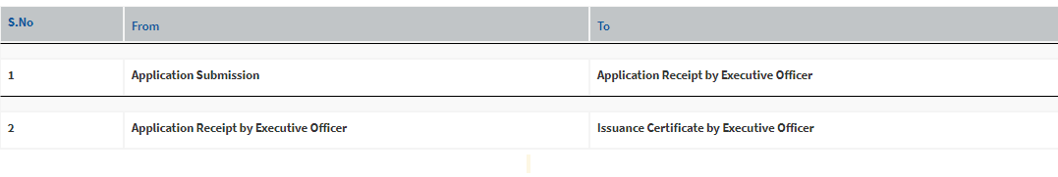

Service Plus Generated Flow Chart:

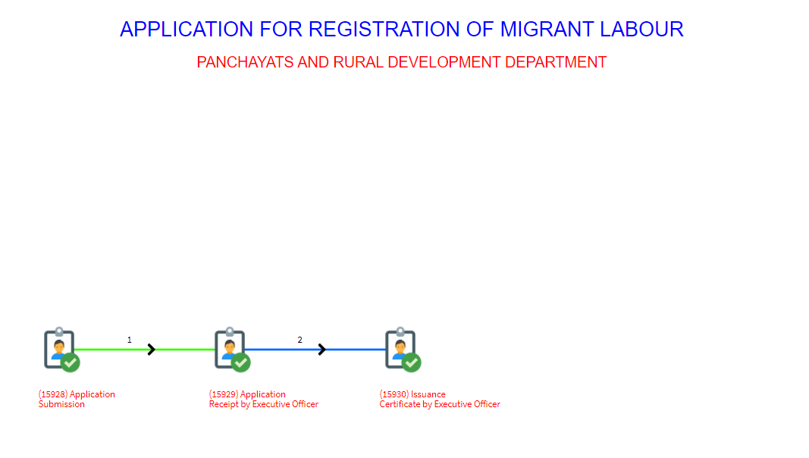

***Flow Chart for Application for registration of Migrant Labour***

***Flow Diagram***

*Computer operator*

**DM OFFICE SECTION**

**1.Labour details submitted.**

**2. Accept the application and save labour detail in database.**

API-1 call to save the labour

**DM OFFICE SECTION**

**3. Search for vacancy .if available than allot to employer and generate certificate.**

API-2 call to search the vacancy.

END

**Description**

**STEP 1:** BDO office computer operator enter the migrant labour application details. He verifies the details and submits the application on behalf of the migrant labour.

**STEP 2:**  DM office receives all the applications submitted at the various BDO/GP offices. A webservice runs to update the migrant labour table with all the application details of the labour.

**API 1 Call-SP send JSON (labour details which are -: experience,** **expected_job,** **expected_salary,** **identity_proof,** **identity_no,** **sp_app_no,** **district,** **block_or_municipality,** **gp_name_or_word_no,** **migrant_worker_name,** **father_husband_name,** **sex,** **date_of_birth,** **age,** **residential_address,** **mobile_no,** **gen_qualification,** **tech_qualification,** **skilled_or_unskilled,** **work_state_name,** **service_name,** **area_type,** **municipality) and Portal save the data in database and Portal send response(status- 0 for unsuccessful and 1- for successful updation in database and 2-for same application number).**

**STEP 3:** DM office will allot a labour to a particular employer if vacancy available and generate the appointment letter for the labour. A web service will run where the labour status will changed as "Employed" and the employer labour requirement for a particular skill will reduced in the employer table. The service for this particular labour application will deliver and closed.

**API 2 Call-SP send JSON (INPUT-: sp_app_no and OUTPUT -:name_employer, employer_address, contact_person_name,contact_person_email,contact_person_mobile, contact_person_designation, sp_app_no_emp_service ) and Portal send response(status- 2 for unsuccessful).**